IELTS PIE CHARTS:

**The charts below show the proportions of British students at one university in England who were able to speak other languages in addition to English, in 2000 and 2010.** Summarise the information by selecting and reporting the main features, and make comparisons where relevant. Write at least 150 words

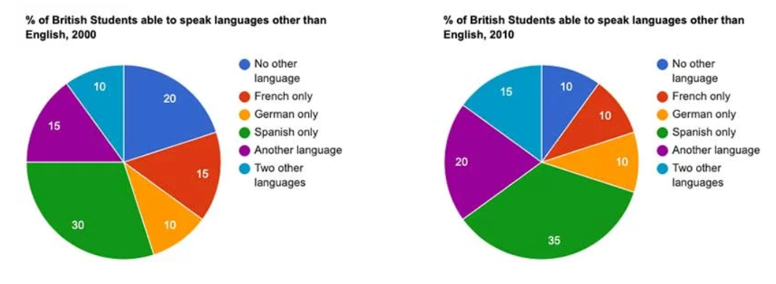**Introduction:** We can paraphrase the question by adding or changing the graph title, graph type, graph scale, and period of the scale. It is important to note that paraphrasing does not require changing every piece of information, and synonyms are the best way to produce effective paraphrasing.

**Introduction 1:** The provided pie charts illustrate the percentage of British students who were able to speak various foreign languages at university in the years 2000 and 2010.

**Introduction 2:** The given pie charts present data regarding the various languages spoken by British students at a UK university, excluding English, in 2000 and 2010.

**Introduction 3:** The given pie charts illustrate the percentage of British pupils who were able to speak different types of foreign languages at university in the years 2000 and 2010.

**Overview:** (Choose 2-4 most significant features you observe and write them in general terms. Main features are highest/lowest, increasing/decreasing trend, constant trend, overall significant difference or similarities, Volatile or fluctuation situation, or any significant exceptions. Don’t write the figures of the scale in this portion)

**Overview 1:** Overall, the Spanish language was the most spoken foreign language for British students, and the least spoken was German. However, all languages experienced changes except German language.

**Overview 2:** Overall, the most spoken language by British students was Spanish, and the least spoken was German, which remained the same in both years.

**Body1:**

According to the data presented in the chart, Spanish had the highest proportion of students in both 2000 and 2010, accounting for 30% and 35%, respectively. Similarly, another language experienced a similar increase, reaching 20% in 2010, while two other languages accounted for 15%. These options became the second and third favorite languages in 2010.

**Body 2:**

By contrast, the percentage of students who spoke no other language decreased significantly, dropping by half to 10% in 2010. Additionally, the portion of students who spoke French declined from 15% to 10% during the same period. However, the proportion of German speakers remained steady at 10% in both years.

**Complete Task:**

The given pie charts illustrate the percentage of British pupils who were able to speak different types of foreign languages at university in the years 2000 and 2010.

Overall, the Spanish language was the most spoken foreign language for British students, and the least spoken was German. However, all languages experienced changes except German language.

According to the data presented in the chart, Spanish had the highest proportion of students in both 2000 and 2010, accounting for 30% and 35%, respectively. Similarly, another language experienced a similar increase, reaching 20% in 2010, while two other languages accounted for 15%. These options became the second and third favorite languages in 2010.

By contrast, the percentage of students who spoke no other language decreased significantly, dropping by half to 10% in 2010. Additionally, the portion of students who spoke French declined from 15% to 10% during the same period. However, the proportion of German speakers remained steady at 10% in both years.

(160 words)